**MODULE 1 ASSESSMENT**

1. Create a file and add executable permission to all users (user, group and others)

$ cat > module.txt #creating a file and adding text

Janani engineer 1234

Yamuna doctor 12345

$ ls -l module.txt #checking the file permission before

-rw-rw-r- - 1 ubuntu ubuntu 41 Jan 24 01:53 module.txt

$ chmod a+x module.txt #adding executable permission for all user

$ ls -l module.txt # verifying the file permission after

-rwxrwxr-x 1 ubuntu ubuntu 41 Jan 24 01:53 module.txt

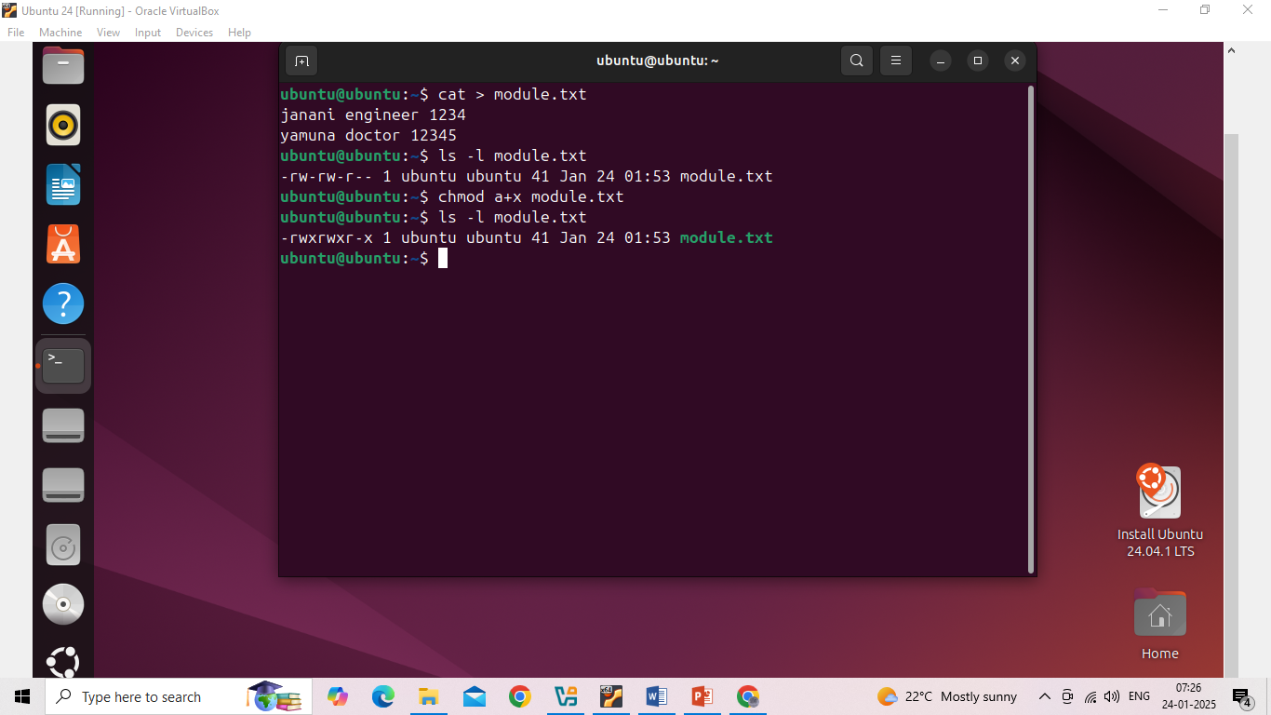

1. create a file and remove write permission for group user alone.

$ touch myfile.txt #creating an empty file

$ls -l myfile.txt #checking the current file permission

-rw-rw-r- - 1 ubuntu ubuntu 0 Jan 24 02:21 myfile.txt

$ chmod g-w myfile.txt #removing the write permission for group user

$ ls -l myfile.txt # verifying the file permission after

-rw-r- -r- - 1 ubuntu ubuntu 0 Jan 24 02:21 myfile.txt

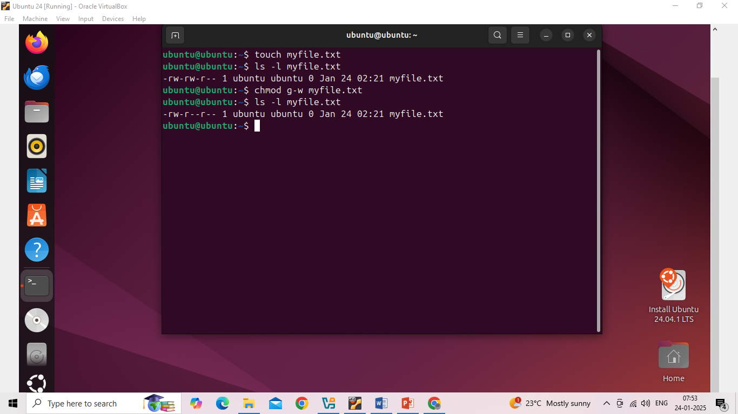

1. Create a file and add a softlink to the file in different directory (Eg : Create a file in dir1/dir2/file and create a softlink for file inside dir1)

$ mkdir dir1 dir2 # creating 2 different directories

$ touch dir1/file.txt # creating an empty file in directory1

$ ln -s ../dir1/file.txt dir2/file_link #adding the softlink to the file in dir2

$ ls -l dir2 #verifying the directory2

lrwxrwxrwx 1 ubuntu ubuntu 16 Jan 24 03:01 file_link -> ../dir1/file.txt

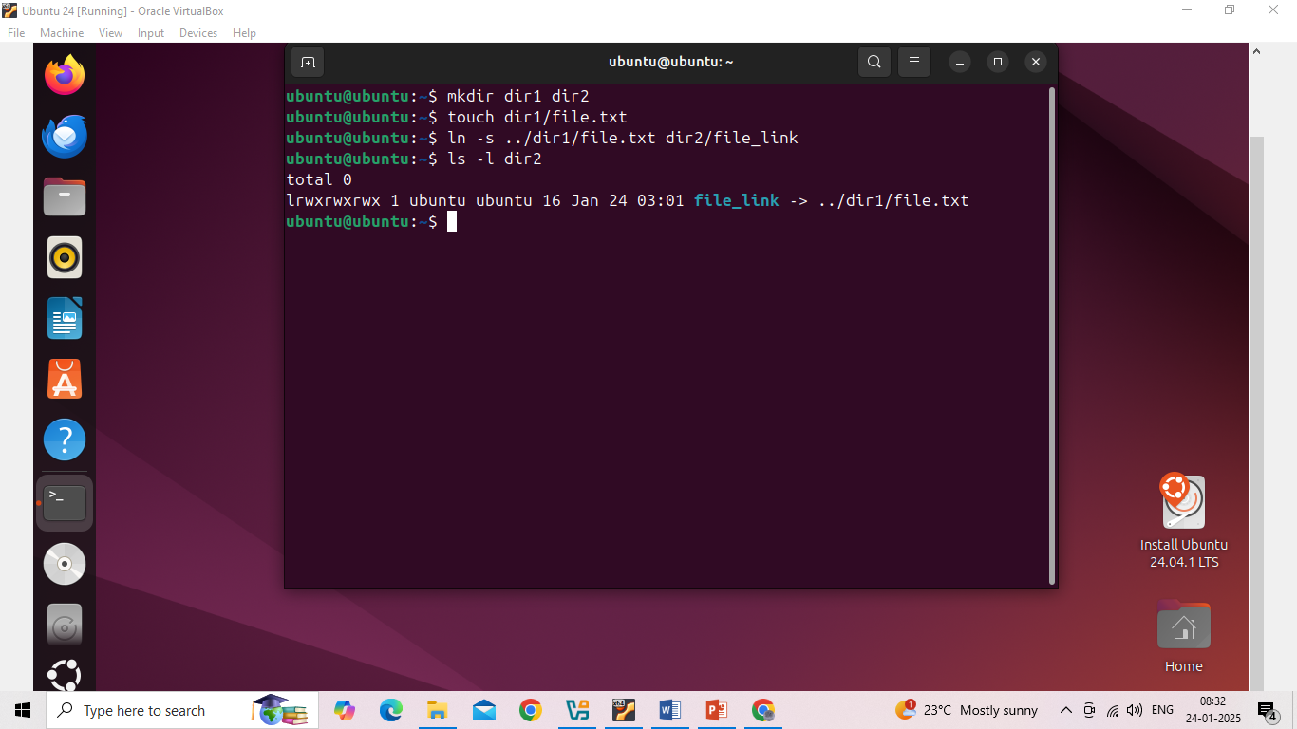

1. Use ps command with options to display all active process running on the system

$ ps -ef # list all active process in a full format list

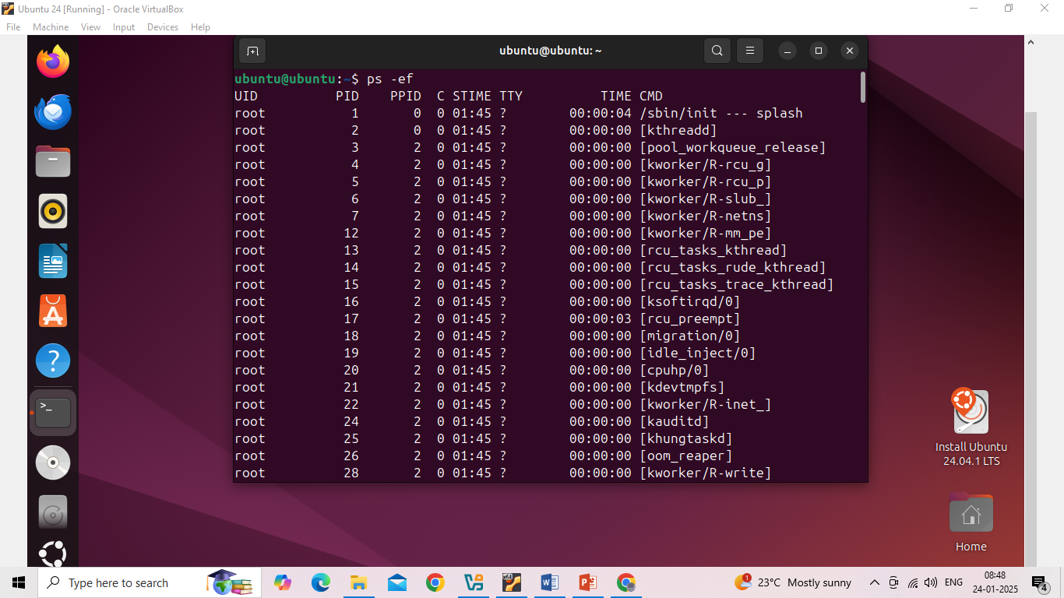

$ ps -ux #used to monitor the user owned process in detail manner

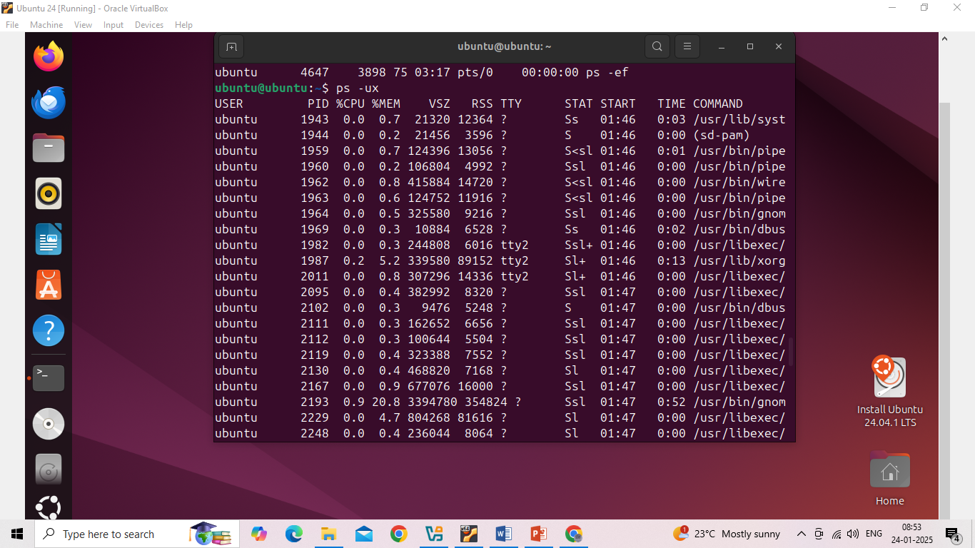

$ ps -G root #Process selected by group name

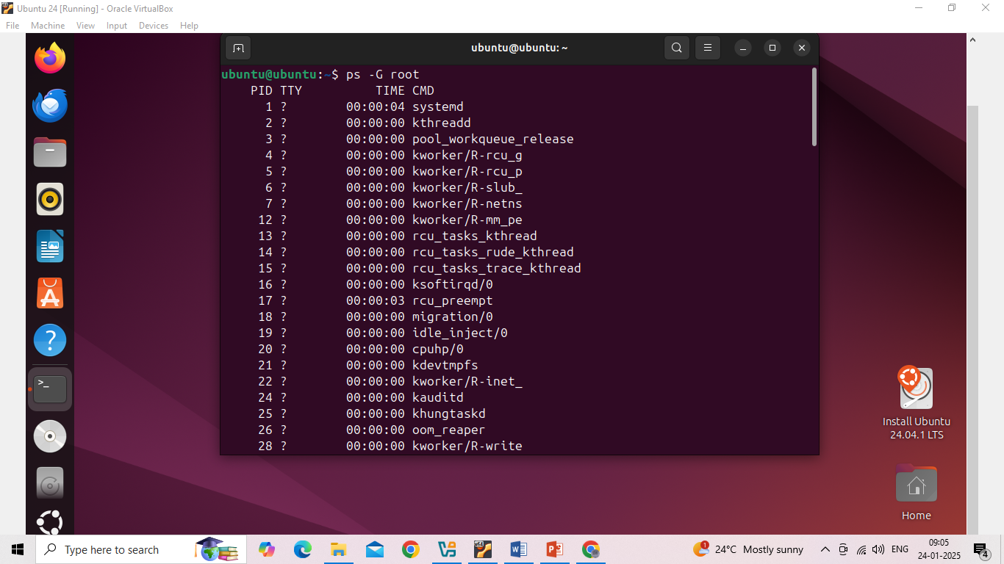

1. Create 3 files in a dir1 and re-direct the output of list command with sorted by timestamp of the files to a file

$ mkdir dira #creating a directory

$ touch dira/file1.txt # creating 3 files in the directory

$ touch dira/file2.txt

$ touch dira/file3.txt

$ ls -l dira | sort -k 6,7 >dira/output.txt # output of list command sorted by timestamp was redirected to the output.txt file

$ cat dira/output.txt #verifying the output.txt file

-rw-rw-r- - 1 ubuntu ubuntu 0 Jan 24 03:54 file1.txt

-rw-rw-r- - 1 ubuntu ubuntu 0 Jan 24 03:54 file2.txt

-rw-rw-r- - 1 ubuntu ubuntu 0 Jan 24 03:54 file3.txt

